Required Capstone Checkpoint 1.1: Evaluating When Retrieval Is Required

Directions

Select one of the provided capstone scenarios and use it as the foundation for this checkpoint. You will continue developing this same scenario throughout the program. Download this worksheet and save a copy to your device before you begin working. Type your responses directly into the document, save your completed work, and upload the finished file when you are ready to submit.

Use this worksheet to:
- Analyze how an LLM performs without retrieval
- Document prompts and corresponding model outputs
- Identify limitations and patterns in model behavior
- Determine when retrieval is required
- Reflect on how retrieval quality affects reliability and user trust

1. Selected Scenario and Intended Use
Select your capstone scenario:
☐ Research Paper Navigator
☒ Wikipedia Retrieval Engine
Briefly describe the kinds of questions, tasks, or user interactions your system should support.
System Capabilities & Supported Interactions
The Wikipedia Retrieval Engine acts as an intelligent assistant that helps users easily explore and learn from a large collection of Wikipedia articles about famous people, historical events, places, and general concepts.
The system supports four main types of user interactions:
- Answering Factual Questions: Users can ask direct questions to get quick, specific facts, such as inquiring about a person's birth date, a historical event's location, or a scientific definition.
- Citation: The system should support both single-document and multi-document questions and provide direct quotations from source material
- Supporting Smooth, Back-and-Forth Conversations: The system remembers the context of the conversation. If a user asks a follow-up question like "Where was he born?" or "Can you explain that last point in simpler terms?", the system understands who or what "he" or "that" refers to without needing the full context repeated.
- Providing Grounded Answers with Quotes: To ensure accuracy and prevent false information (hallucinations), the system backs up its answers by citing source Wikipedia articles and including direct, word-for-word quotations so users can instantly verify the facts.

2. Prompt and Output Evidence
- Provide two prompts relevant to your scenario. Where possible, use prompts that test different types of information needs or tasks.
- Include the corresponding LLM outputs for each prompt.
Prompt 1 and Corresponding LLM Outputs
Prompt with history on
When was the war of 1812?
Response
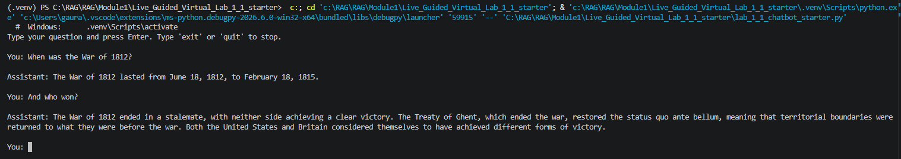

Prompt 2 and Corresponding LLM Outputs
Prompt with history off

Prompt1
When was the war of 1812?

Prompt2
And who won?

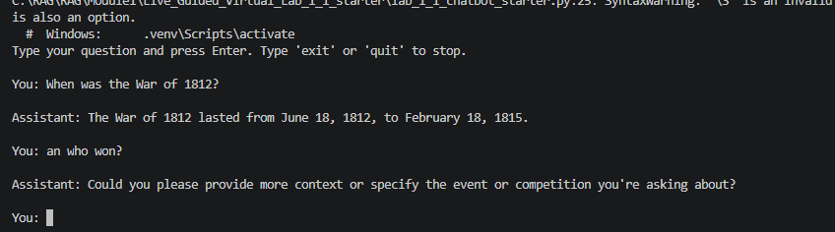

3. Analysis of Model Limitations
- Identify key limitations in the model’s responses, such as hallucinations, knowledge gaps, stale information, inconsistency, vagueness, or missing information.
- Use specific prompt/output examples to support your analysis.
Key limitations and supporting prompt/output examples
Knowledge Gap
Domain Specific Question which was not answered correctly. This is an example of Knowledge Gap
Prompt:
What is the difference between claim and encounter in Healthcare Payer domain?
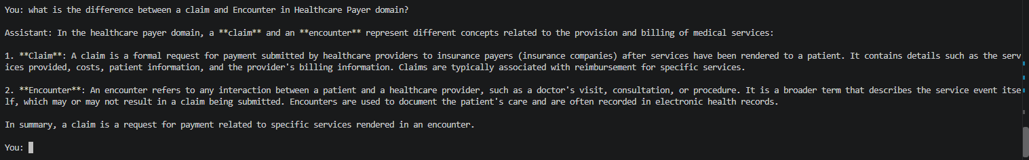
State Information
Prompt: what is the current situation on the strait of hormuz?
It answered what was the state back in October 2023. may be it is not current because of some political reasons
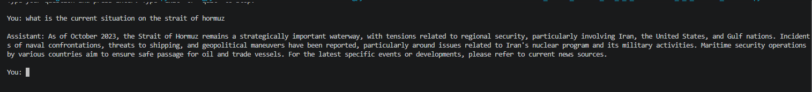
Hallucinations
Prompt: I am getting an error in Momentum-'Bump is identified, Owner's approval is required'. Do you know how to fix it?
I asked a question on proprietary framework called Momentum. I got a answer which is not related, it sounds like more based on common sense and a guess.
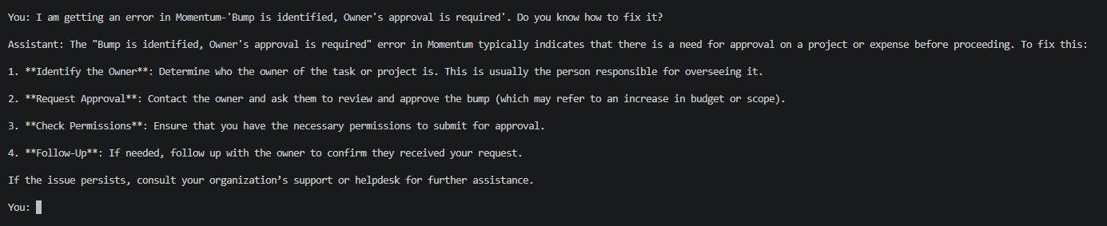

4. Patterns in Model Behavior
- Describe any meaningful patterns or trends you observe across the outputs.
- Consider whether certain types of prompts produce more reliable responses than others.
Meaningful patterns or trends
Response: I have observed a pattern with keyword based search using bm25. It could answer correctly when used abbreviation for CEO and COO. But on follow up question it answered wrong on datetime stamp for follow up email sent by COO, it took first unrelated follow up email’s date time and ignored the context.
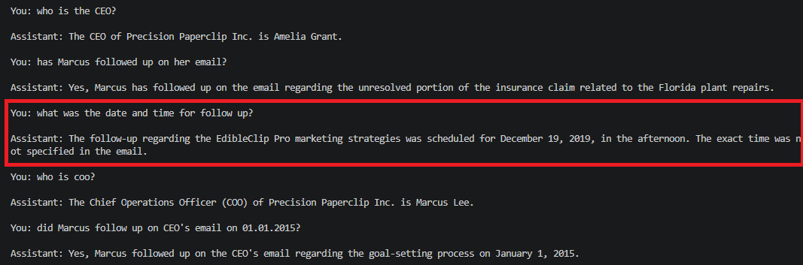
Bm25 seems reliable for non contextual prompt, for simple context it worked but for little more complex context, it answered based on first matched result

5. Determining Whether Retrieval Is Required
- Explain whether retrieval is required for your scenario and identify which observed limitations retrieval could help address.
- Justify your reasoning using evidence from the outputs.
Explanation and justification
As shown in my last prompt about a specific error on proprietary framework Momentum and LLM gave a generic answer based on common sense not specific to the home grown product. In this situation the Retrieval is necessary to increase the accuracy
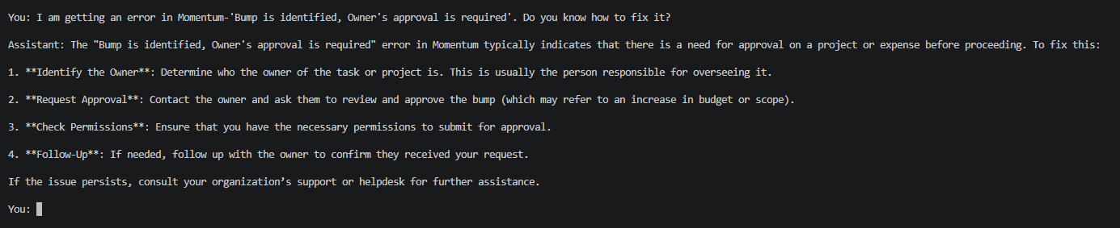

6. Retrieval Requirements
- Describe the types of information that would need to be retrieved to improve reliability, grounding, and response quality. Consider whether the information is proprietary, frequently changing, highly specific, or otherwise unavailable to the model without retrieval.
- Explain when retrieval would or would not be necessary.
Information that would need to be retrieved
Retrieval Required
Retrieval is useful for current news, proprietary framework, products, home grown products, company rules, customer records, product prices, legal updates, and technical documents. It also helps with private or highly specific information the model was not trained on.
As shown in previous examples about current news and proprietary framework
Prompt: I am getting an error in Momentum-'Bump is identified, Owner's approval is required'. Do you know how to fix it?
I asked a question on proprietary framework called Momentum. I got a answer which is not related, it sounds like more based on common sense and a guess.



Prompt: what is the current situation on the strait of hormuz?
It answered what was the state back in October 2023. Maybe it is not current because of some political reasons

Retrieval is not necessary
LLMs can handle and works well on following use cases and retrieval is not required-
- Common domain knowledge available publicly
- General Reasoning like solving math’s problem
- Common computer programming/logic writing and debugging

When retrieval would or would not be necessary
Response:
It improves reliability by grounding answers in real, relevant sources. Retrieval is needed when facts may change or must be exact. It is less necessary for common knowledge, basic explanations, writing help, or tasks that do not depend on current or private information.

7. Reflection and Next Steps
Explain how the precision, relevance, and accuracy of retrieved information affect output quality, system reliability, and user trust. Consider how retrieval quality might improve or degrade system performance. What could happen if the retrieved information is incomplete, loosely related, outdated, or inaccurate?
Explanation
Response: incorrect retrieval causes wrong results. Incomplete information may drop important details; unrelated information will confuse the users; outdated information can suggest something which is of no use now; and inaccurate information can lead to wrong decision. If this pattern is repeated over and over again, the bad answers will make users to lose confidence in the system

8. Retrieval Requirements
- Reflect on what you learned about LLM limitations, common failure modes, and retrieval needs from this activity.
- Describe what you would investigate or improve next as you continue developing your capstone system.
Reflection
Response: Limitations- failed to provide non-public information like my company’s HR policy. Could not answer most recent update which might be deliberate because of some political reasons also.
Common failure modes- failed on follow up questions when conversation history was off, domain specific questions
Retrieval Needs- for non-public information, domain specific knowledge
Improvement-

Supporting Materials
Use this section to list, describe, or link to any supporting materials included with your submission.
Supporting material | Location, link, or note
Solution files, Worksheet are kept in git | https://github.com/merasupermarket/RAG-WITH-MIT-XPRO

End of Required Capstone Checkpoint 1.1
Return to the assignment page in the learning platform to upload and submit your completed capstone checkpoint and complete any remaining items in this module.

